ASSIGNMENT 8
Name-Spandan Deb

Topology
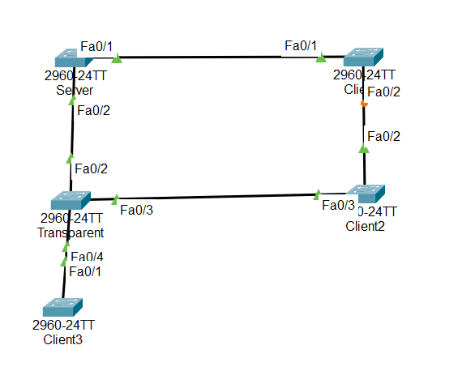

Trunking
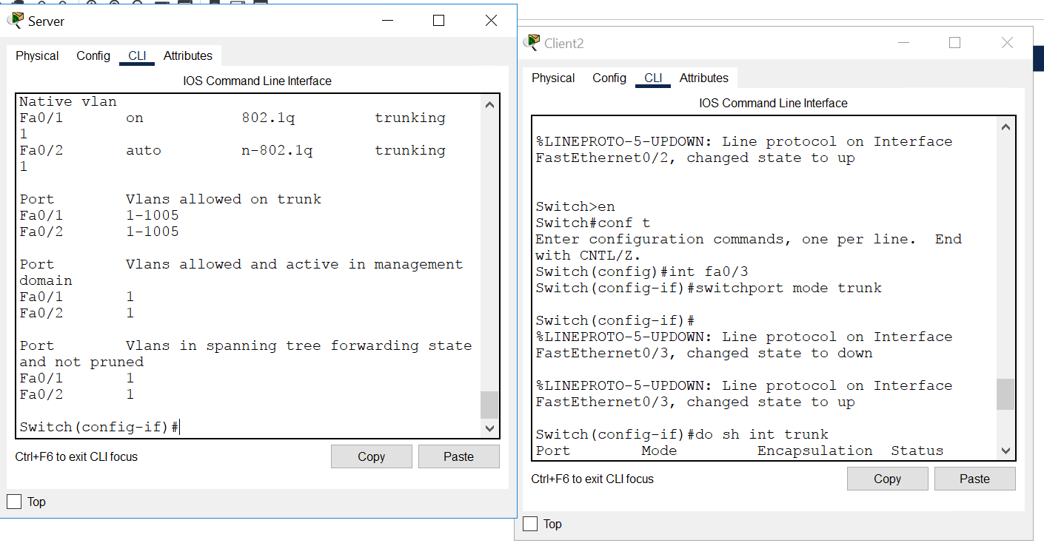

Setting vtp domain name and password
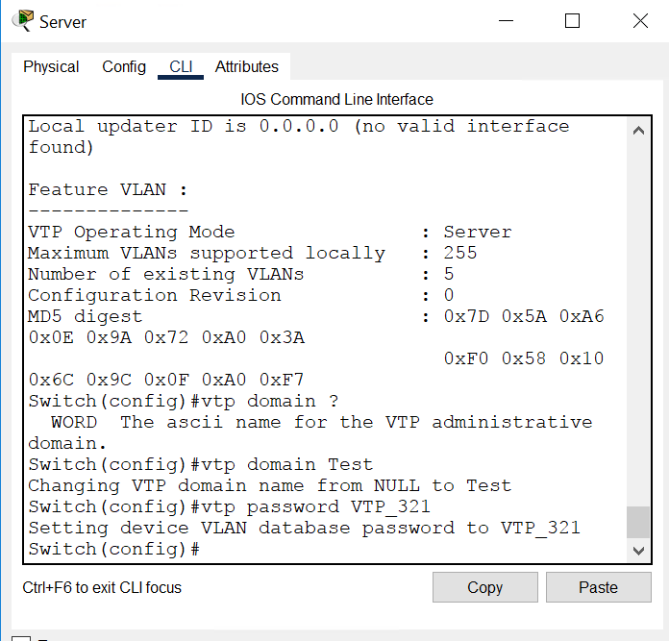

Setting the respective modes like client and transparent no need to set server mode as it is default.
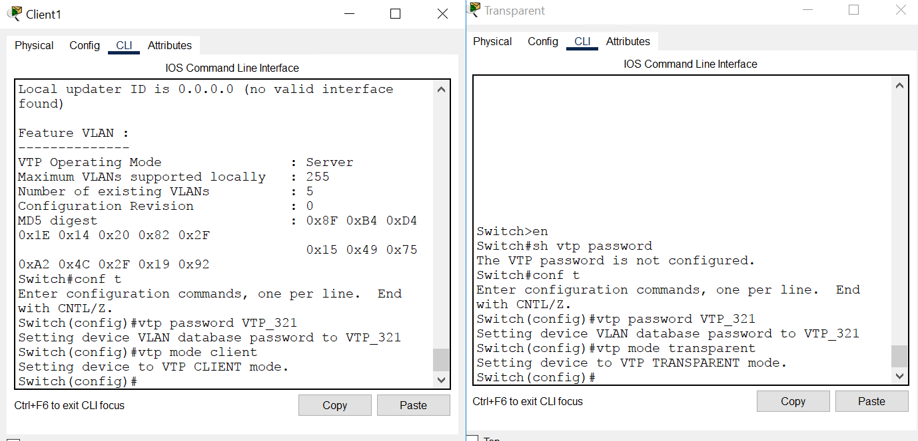

Created 2 vlan on server
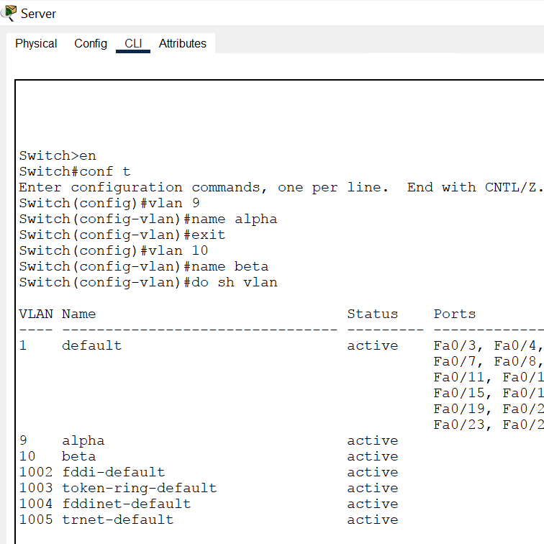

So the same VLAN’s will be there on client switch as well expect transparent switch.
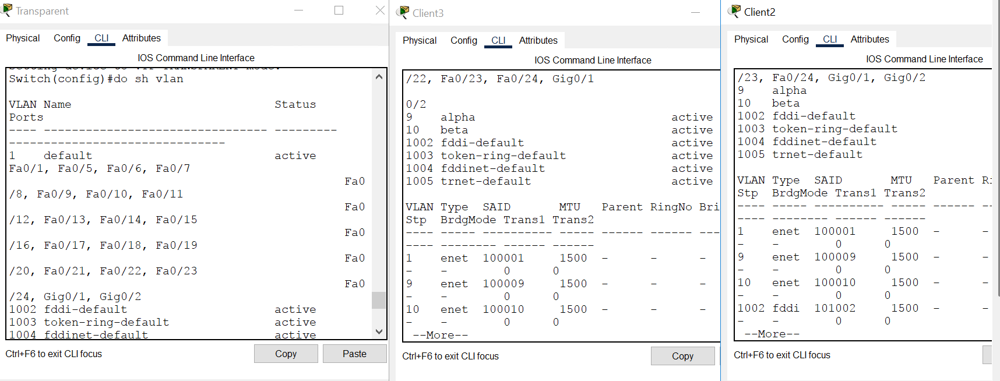

Created VLAN 50 on transparent switch
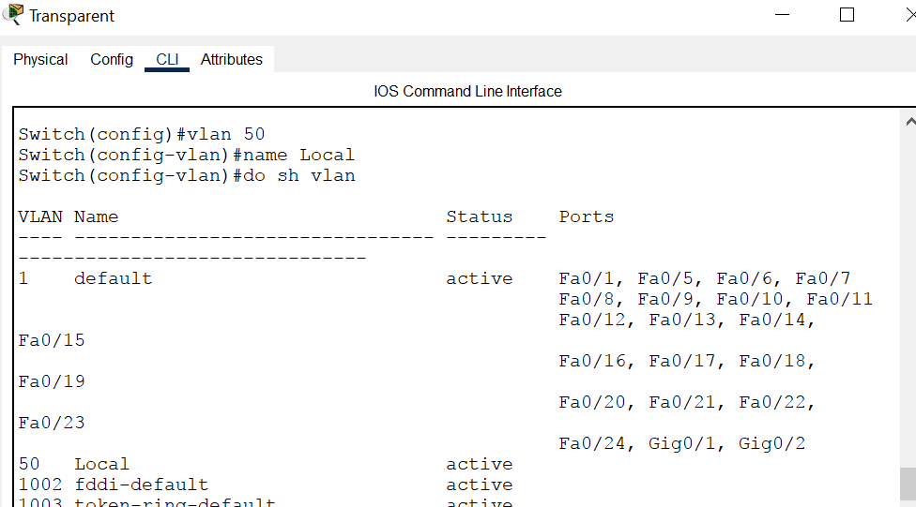

Verification VLAN created on transparent switch is local and is not synced with clients
